Name: Karnati Vinay

Reg No.: 20BCE1942

Java Spring boot Week 3 solutions

Code:

package com.company;  
  
import java.sql.Connection;  
import java.sql.DriverManager;  
import java.sql.ResultSet;  
import java.sql.Statement;  
  
public class Main {  
 public static void main(String[] args) {  
 try{  
 Class.*forName*("com.mysql.cj.jdbc.Driver");  
 // 2.connection  
 Connection conn = DriverManager.*getConnection*("jdbc:mysql://localhost:3306/test", "root", "");  
 // 3.Statement  
 Statement stmt = conn.createStatement();  
 // 4.Execute query  
 ResultSet rs = stmt.executeQuery("select \* from department");  
 while (rs.next()) {  
 System.*out*.println(rs.getString(1) + " " + rs.getInt(2) + " " + rs.getString(3));  
 }  
 // 5.close the conenction  
 conn.close();  
 }  
 catch (Exception e){  
 System.*out*.println(e);  
 }  
 }  
}

Screenshots:

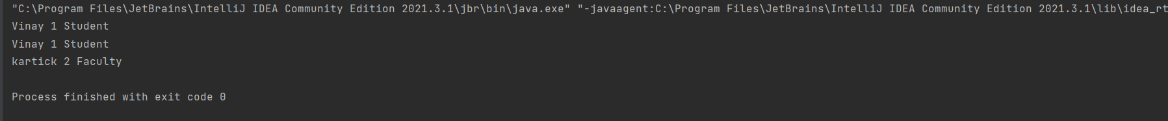

Database Screenshots:

